**Istanbul 5 Nights / 6 days**

**Day 1 – Istanbul**  
Transfer from the airport to your hotel. Day at leisure. Overnight in Istanbul.

**Day 2 – Istanbul (B)  
Full Day Old City Tour:**  
Pick up from your hotel to visit **Topkapi Palace**, with royal treasury and elegant four courts. After lunch, proceed to the**Hagia Sophia**, a great Byzantine architectural masterpiece, whose interior is resplendent with golden mosaics. Then admire the delicate design and Iznik tiles of the **Blue Mosque**. Explore the ancient Roman **Hippodrome** with **Egyptian Obelisk** and**Serpentine Column**. Finally, stop off at the dazzling **Grand Bazaar**with over 4000 shops. Drop off to hotel. Overnight in Istanbul.

**Day 3 – Istanbul (B)   
Full Day Bosphorus & Two Continents Tour:**  
Pick up from your hotel to visit the bustling **Spice Market** – a colorful bazaar heaped with various sweets and spices. Then you’ll take a **relaxing Bosphorus boat cruise** (by public ferry or Zoe Yacht) between the continents of Europe and Asia – gliding past Dolmabahce and Beylerbeyi Palaces, ornate wooden Ottoman mansions and mosques, Rumeli Fortress and the Bosphorus Bridge. In the afternoon, visit the beautiful **Beylerbeyi Palace** following by a scenic stop on **Camlica Hill** for panoramic views over Istanbul. Drop off to hotel. Overnight Istanbul.

(**Recommended Option**: Upgrade to a [Breathtaking Bosphorus Cruise by ZOE Yacht](http://www.byzastoursturkey.com/bosphorus-tour-istanbul/)Teamed with Byzas Tours, a private cruise on Zoe Yacht offers the opportunity to enjoy the best possible Bosphorus experience with**Comfort, Unique Views & a Relaxing Environment**as key for you and your companion/s only. Highly recommended.

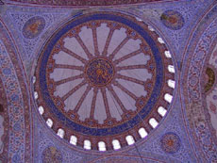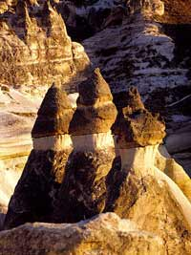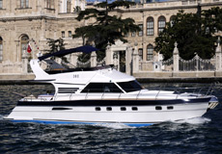

**Day 4 – Cappadocia (L)  
Full Day Cappadocia Tour 1:**  
Airport transfer and fly to Cappadocia. Transfer to the tour. Start with a gentle walk through orchards, unusual volcanic rock formations and rock-cut houses at **Red & Rose Valley**. Visit the old **Christian Village of Cavusin**, followed by lunch and then an excursion to **Pigeon Valley**. In the afternoon, visit **Kaymakli Underground City**, which hid local Christians from Arab invaders, **Ortahisar Castle** and **Mustafapasa Greek village**. Drop off to hotel. Overnight in Cappadocia.

**Day 5 – Cappadocia (B, L)  
Full Day Cappadocia Tour 2:**  
Pick up from your hotel after breakfast to explore **Devrent and Monk’s Valley**, to see the extraordinary mushroom-shaped rock pinnacles or**‘fairy chimneys’**. Continue on to the small village of **Avanos**, famous for clay pottery design. After lunch, proceed to the **Goreme Open Air Museum**, featuring the most impressive **rock-carved churches**and **Byzantine frescoes** in all Cappadocia. Finally enjoy a view of the moonscape valleys from the rock-perched natural**citadel at Uchisar**. Drop off to hotel. Overnight in Cappadocia.

**Day 6 – Cappdocia-Istanbul (B)**Transfer to Cappadocia airport. Fly back to Istanbul, or onward extension.